C1 GRAMMAR

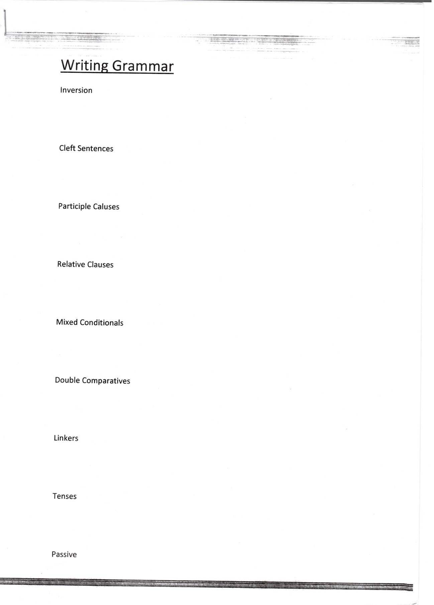

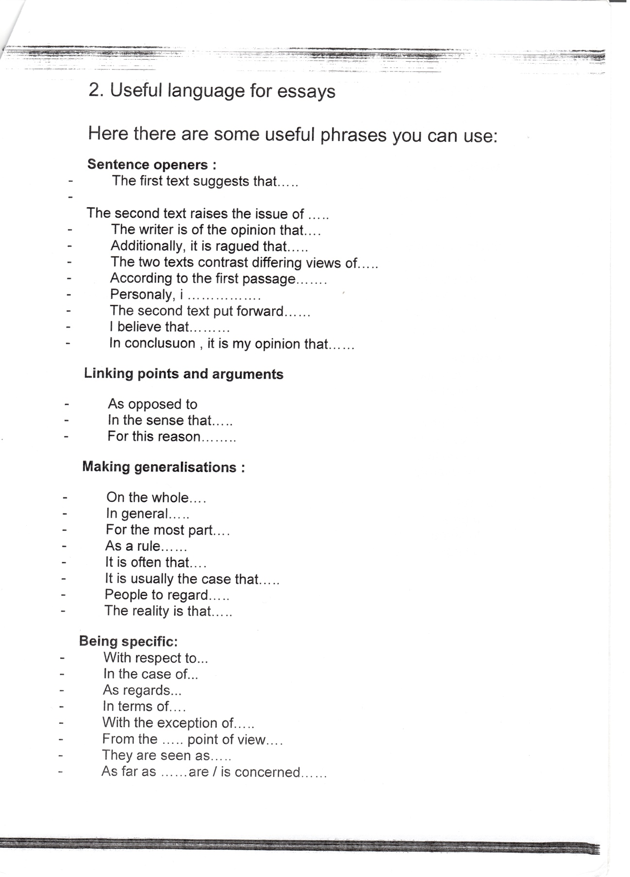

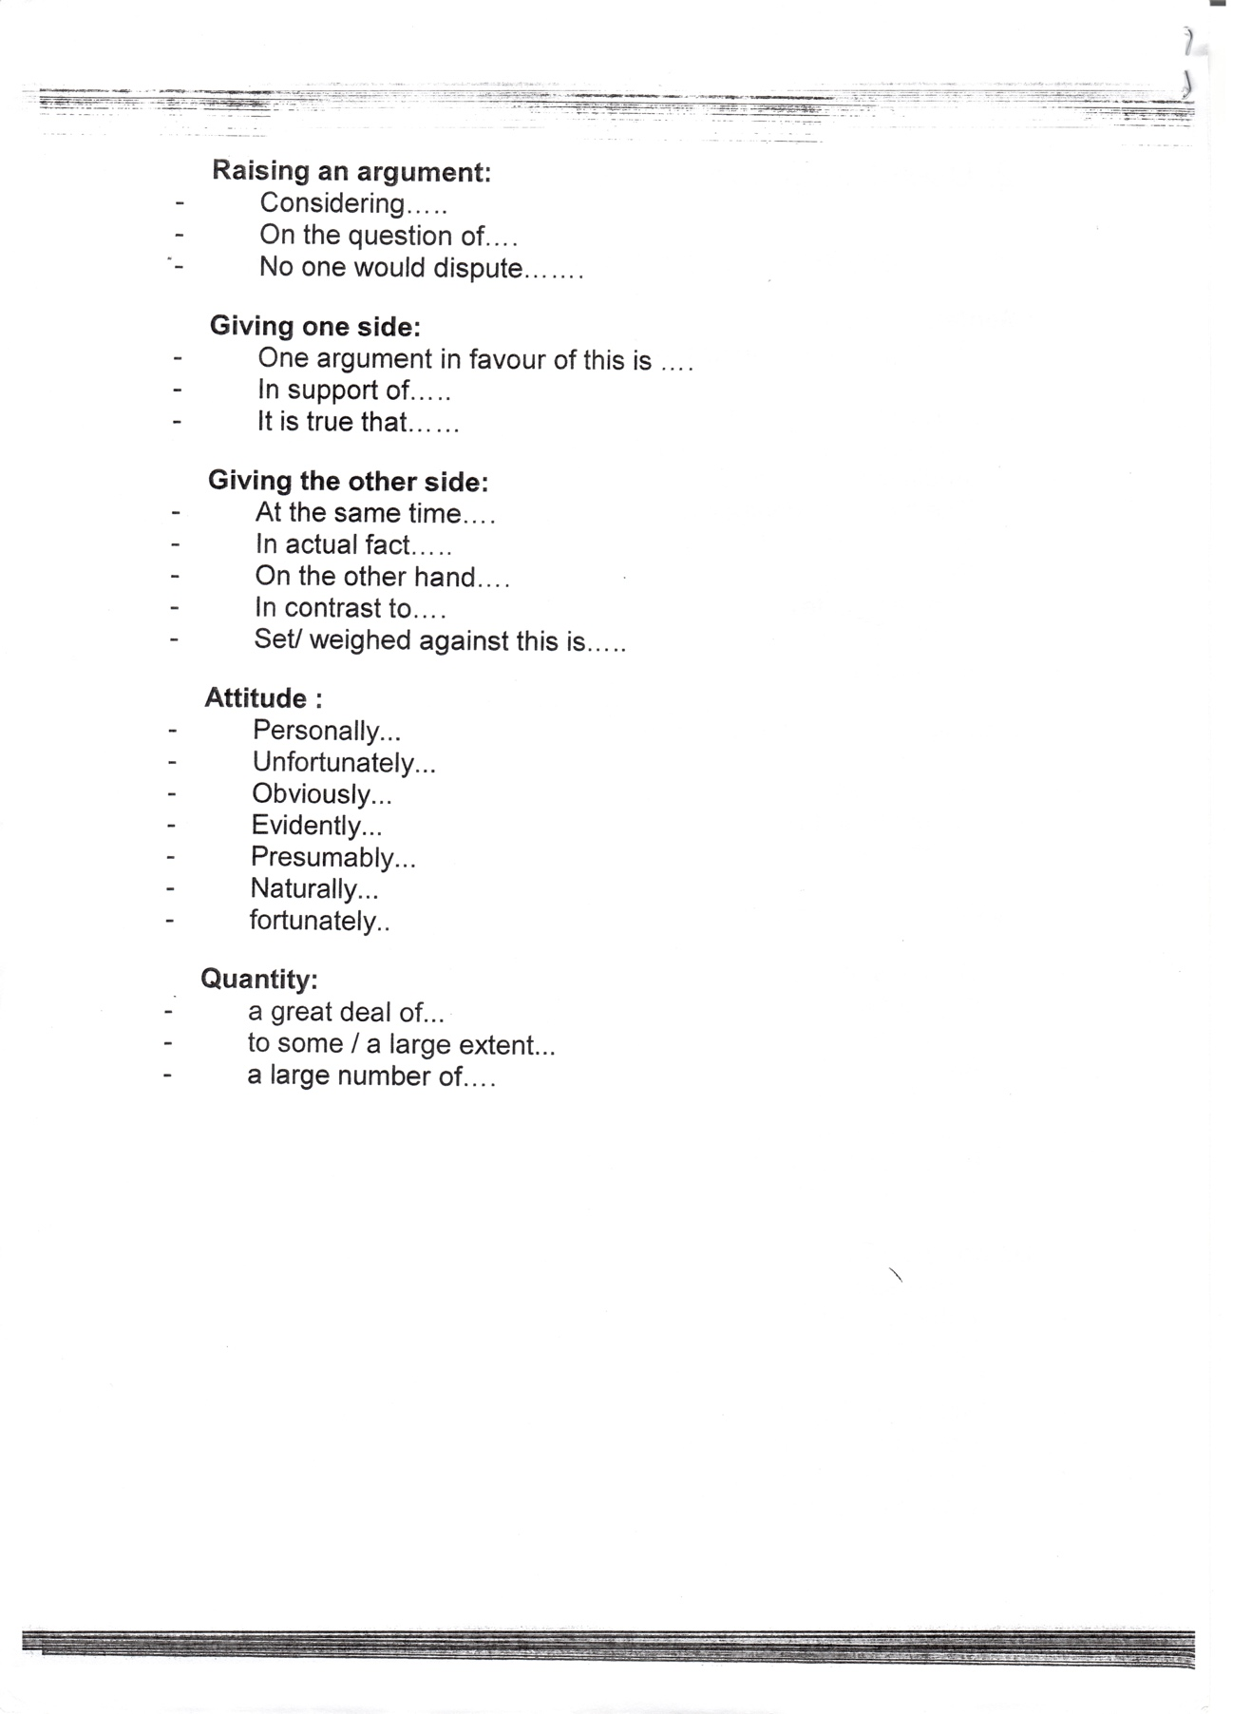

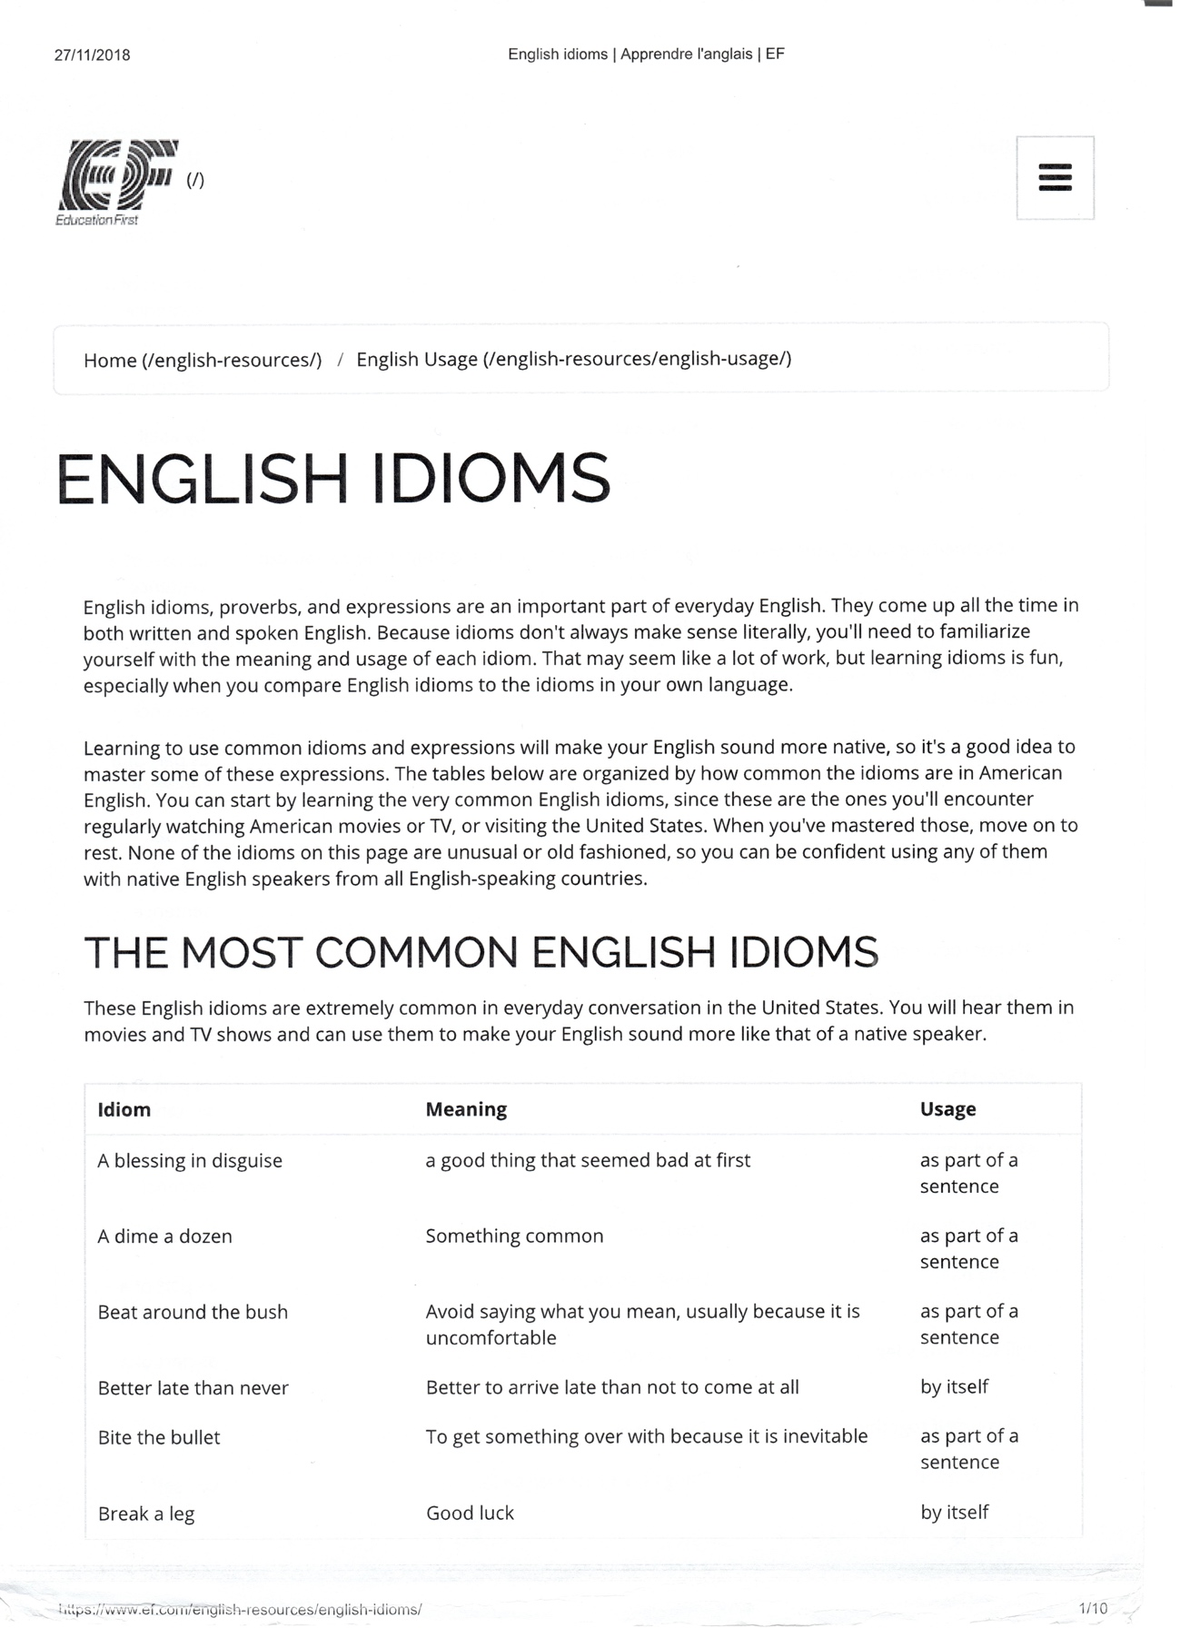

Every cloud has a silver lining

Break/hit the glass ceiling

We’ll cross that brigde when we come/get to it

Break the ice / break sth down [for someone]

*[Call (it) here] [Get around] [Get along] [Show up]*

*[Pull through] [Go through]*

